# **Azure Data Factory**

This demo deals with the creation of user interface for Azure Data Factory. Here we will be creating storage account, pipeline, datasets and will monitoring the data factory. Triggers will also be executed with the same.

**Creating Azure Storage Account:**

Go to **+ Create New resource** and choose **Storage->Storage Account.** Give an unique name, and choose the same location that is given in the image below. Choose a resource group and click on create.

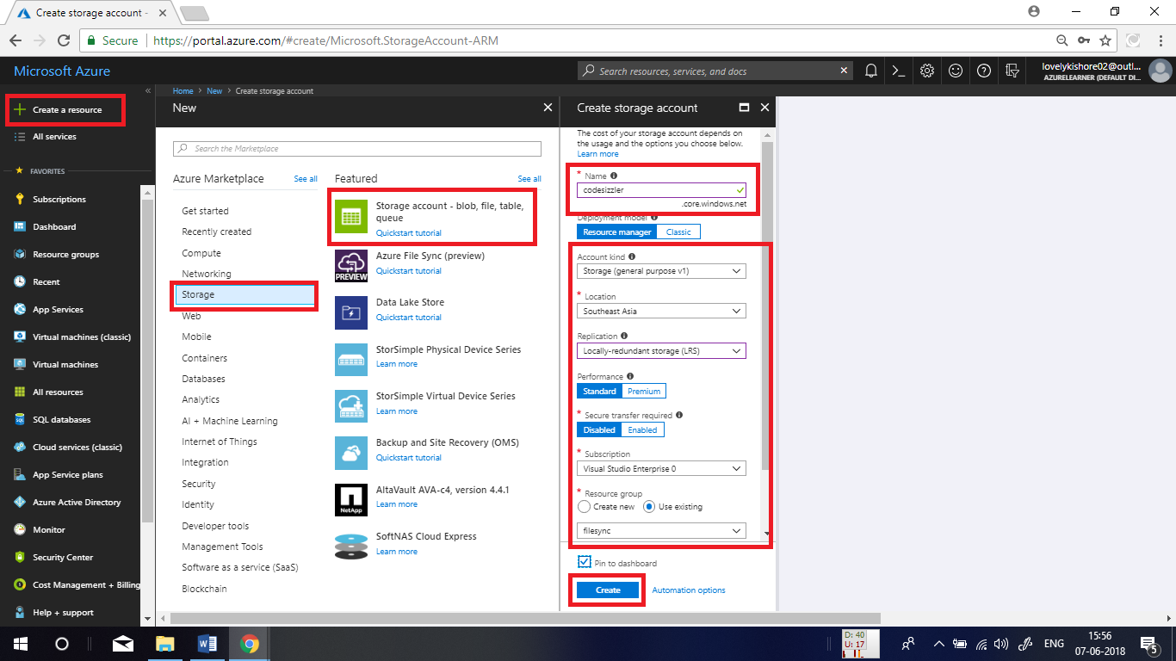

**Creating a Container:**

Now, create a container to copy the data that you are going to copy using pipeline. To do this, go to overview page of the storage account that you created and click on **Blobs.**

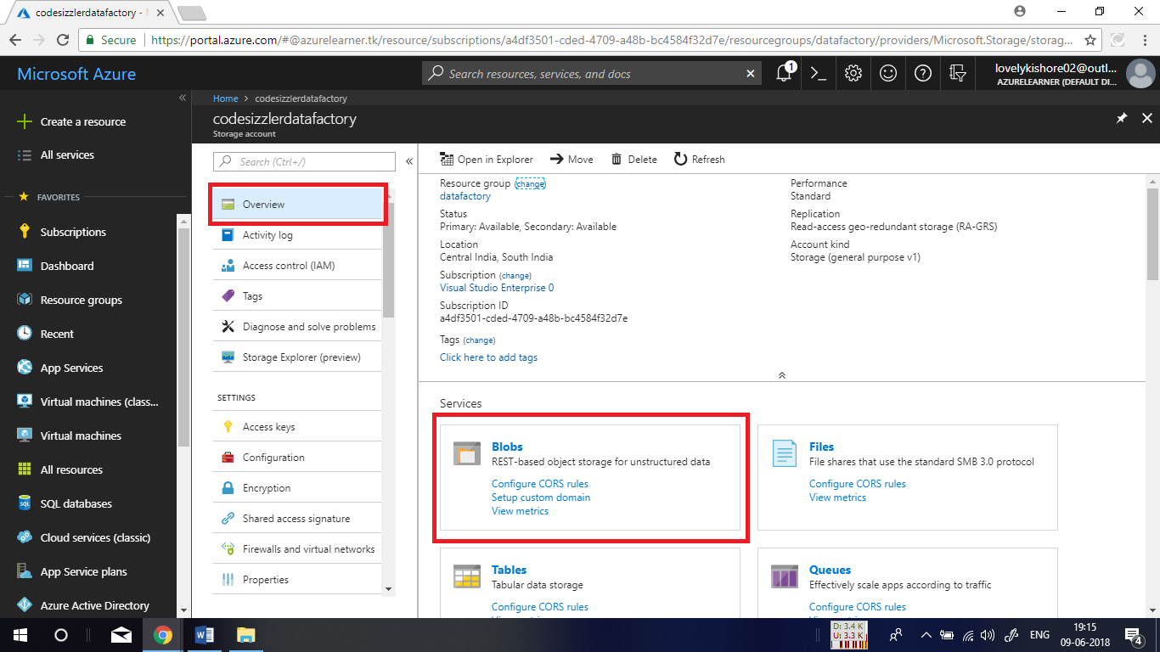

Then click on **+Container** and give a name for the container and click on ok.

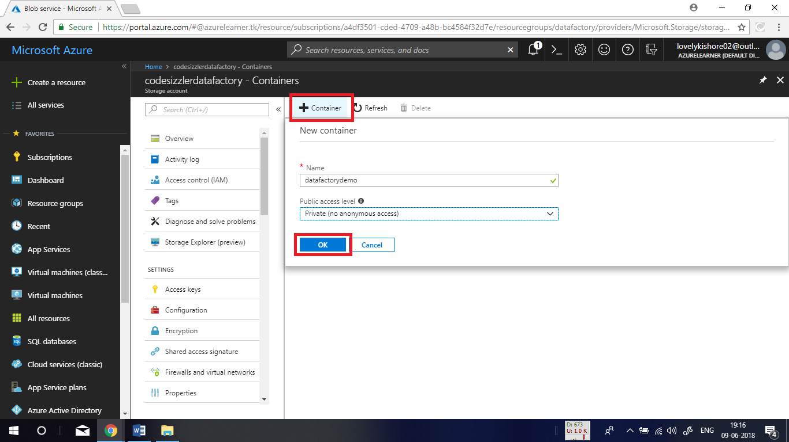

After creating the container, click and open its overview page.

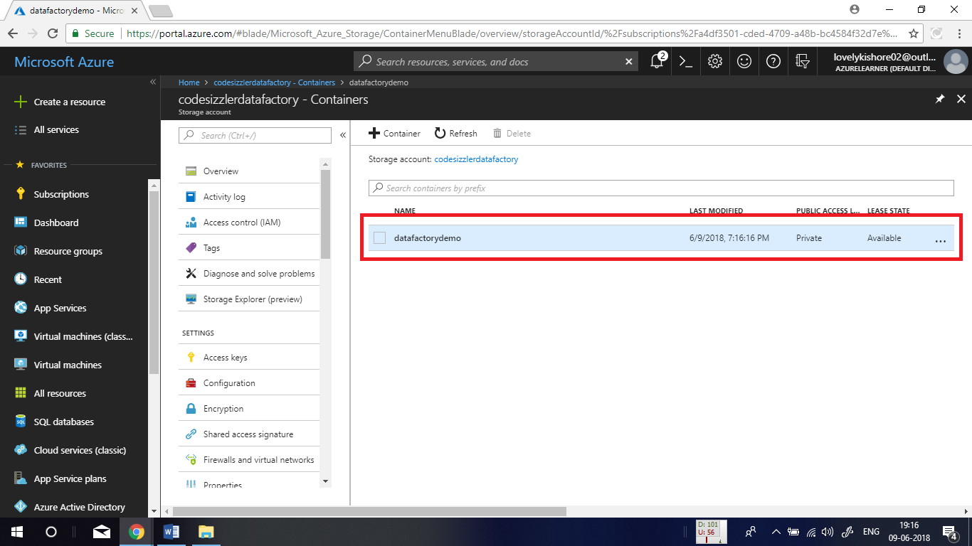

Click on the **Upload** at the top and choose any file that you like to copy. Create a new folder ad done below and click on Upload. This will upload the blob into your container.

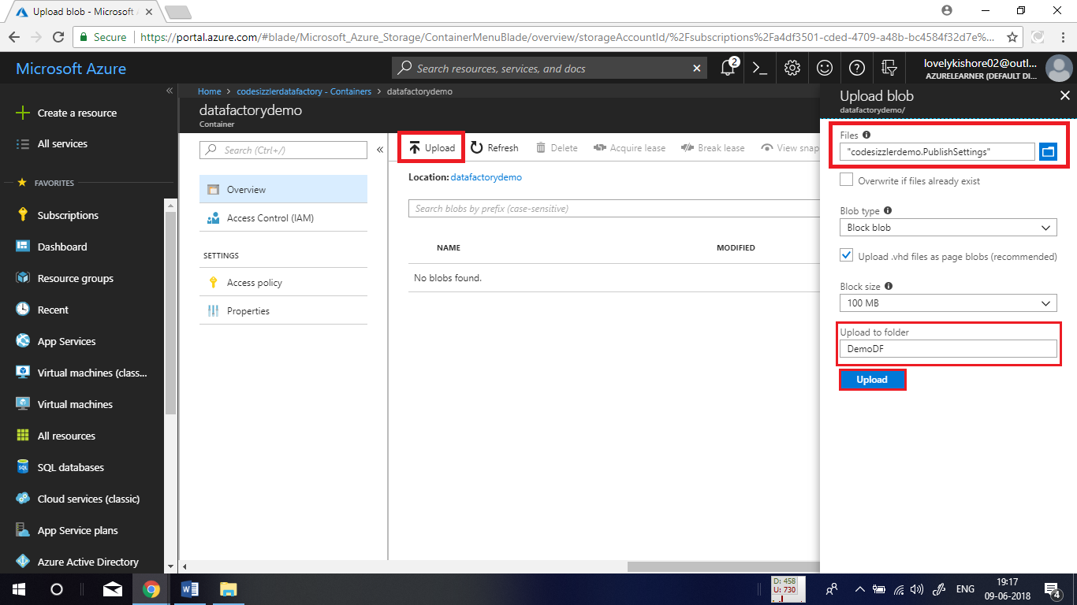

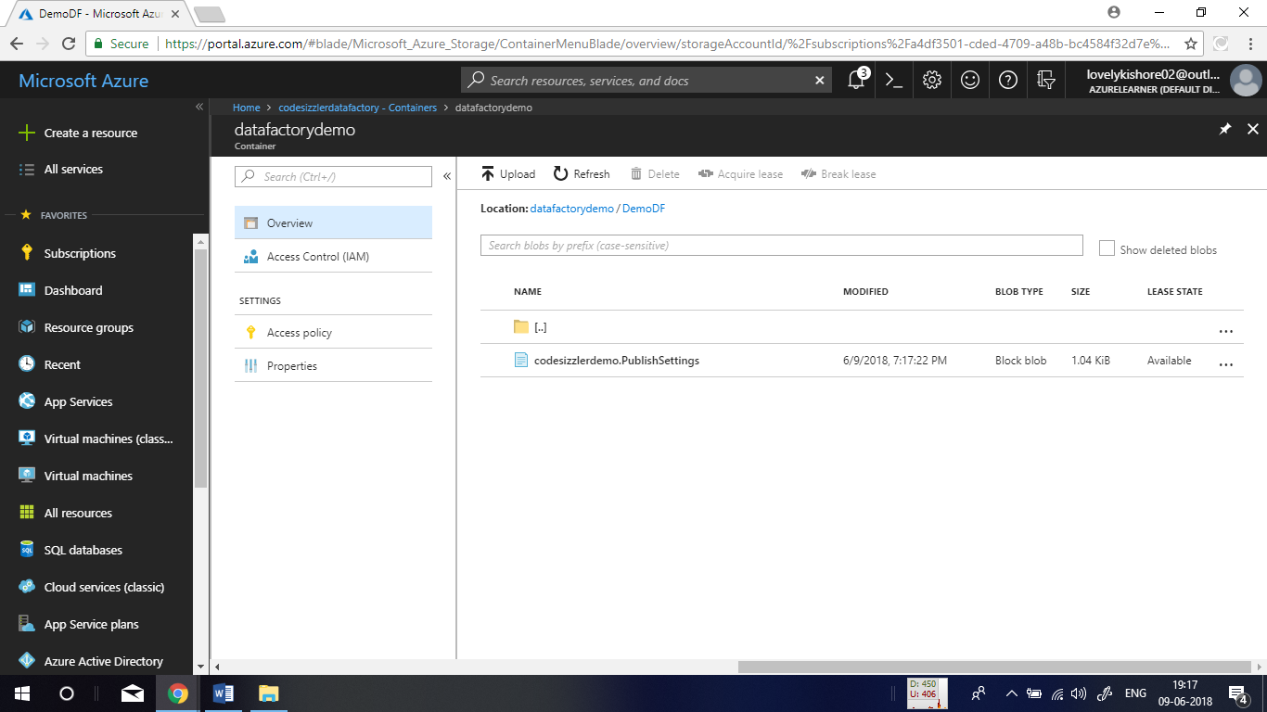

**Creating Data Factory:**

In the Azure portal, go to **+ Create Resource -> Analytics -> Data Factory.** Give a **name** for the resource, select a **subscription**, a **resource group**, **version**, **location** and click on **Create.**

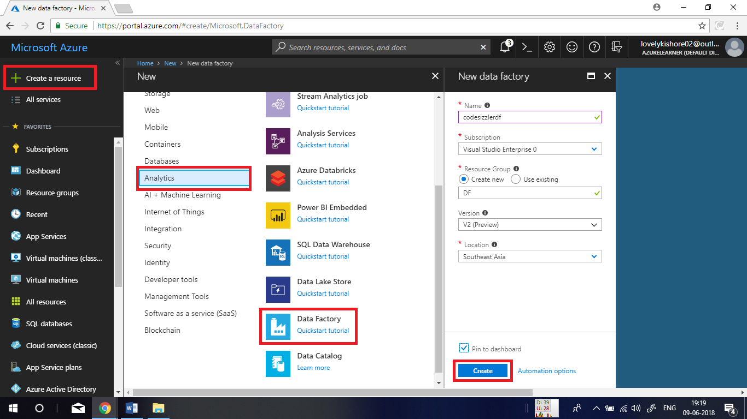

In the overview page of the data factory, click on **Author & Monitor** tile to navigate into management portal of azure data factory.

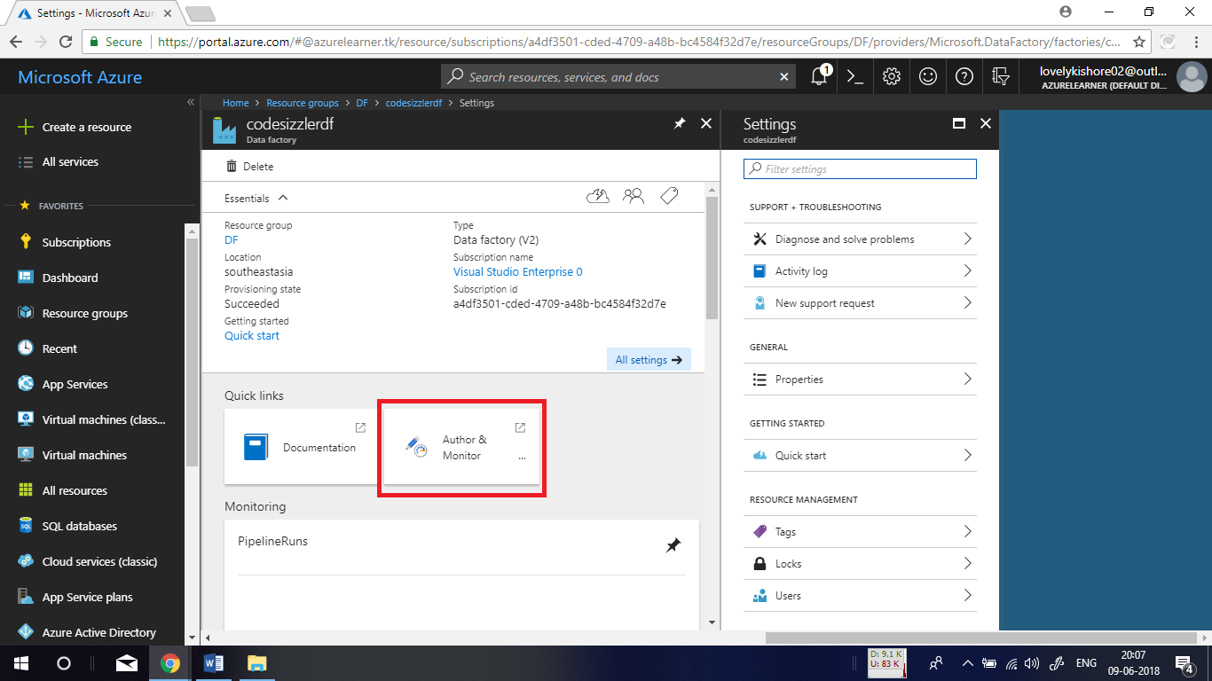

**Adding Connection Data Factory:**

In the management portal, click on **Connections** button in the bottom and click on **+New** to add a connection.

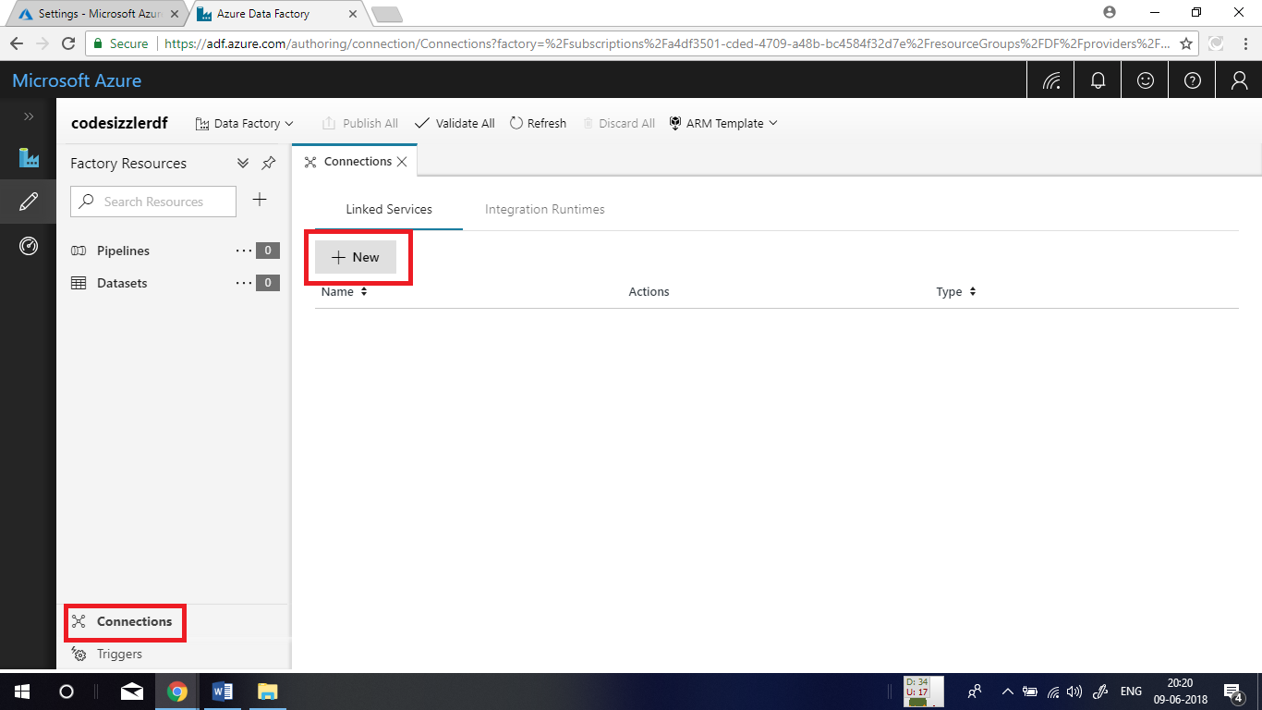

After that, choose **Azure Blob Storage** I data store and click on continue.

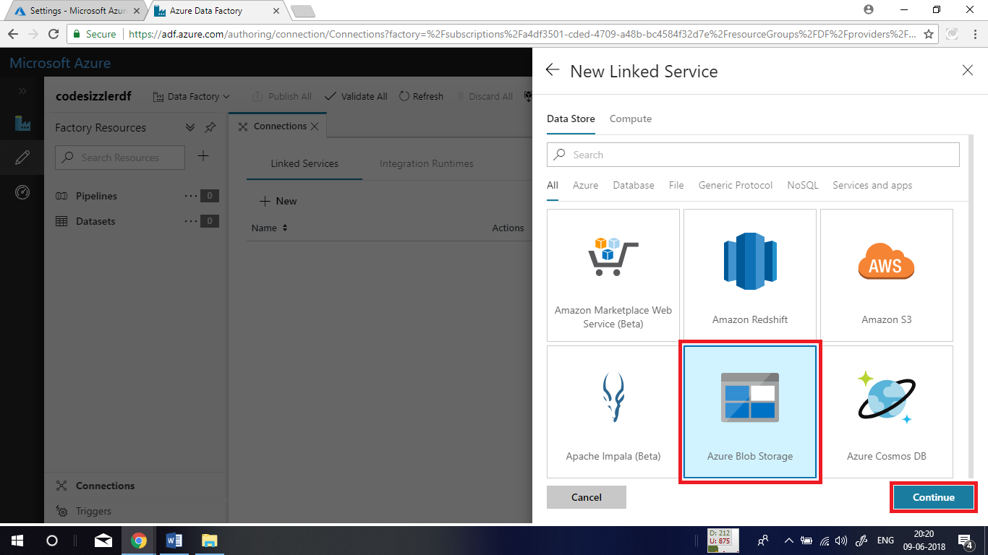

In the next blade, give a name for the connection. For authentication to storage account, choose **Connection String.** Choose the storage account and subscription as denoted below and test connection by clicking on **Test Connection.** If the connection succeeds, click on **Finish** button.

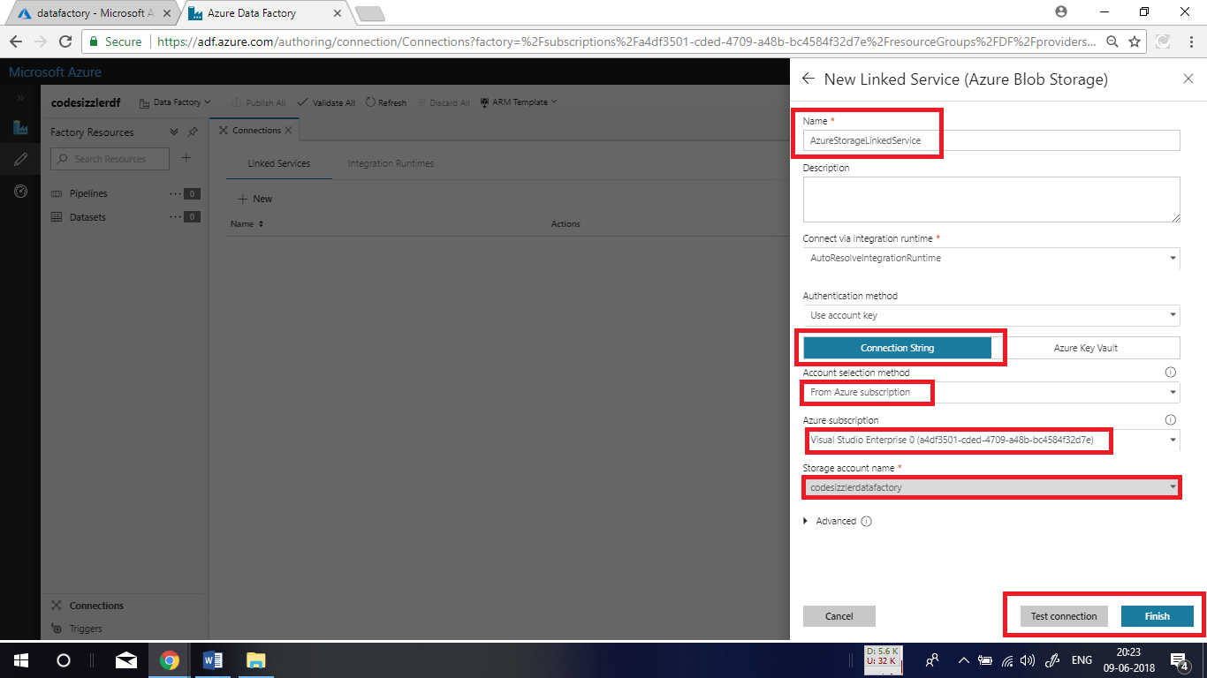

After you complete the process, you will be getting a connection created as shown below.

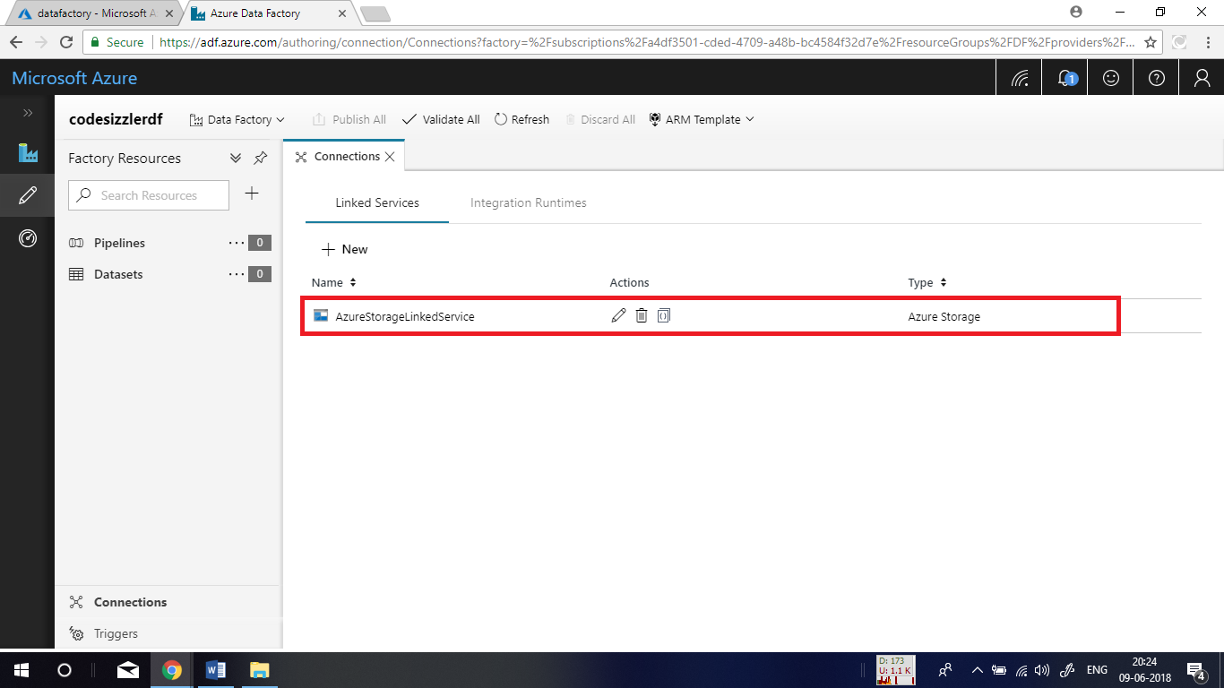

**Creating datasets:**

In the left side pane click on **+** button and choose **Dataset** as shown below. Next choose **Azure Blob Storage** in **Data Store** and click on **Finish.**

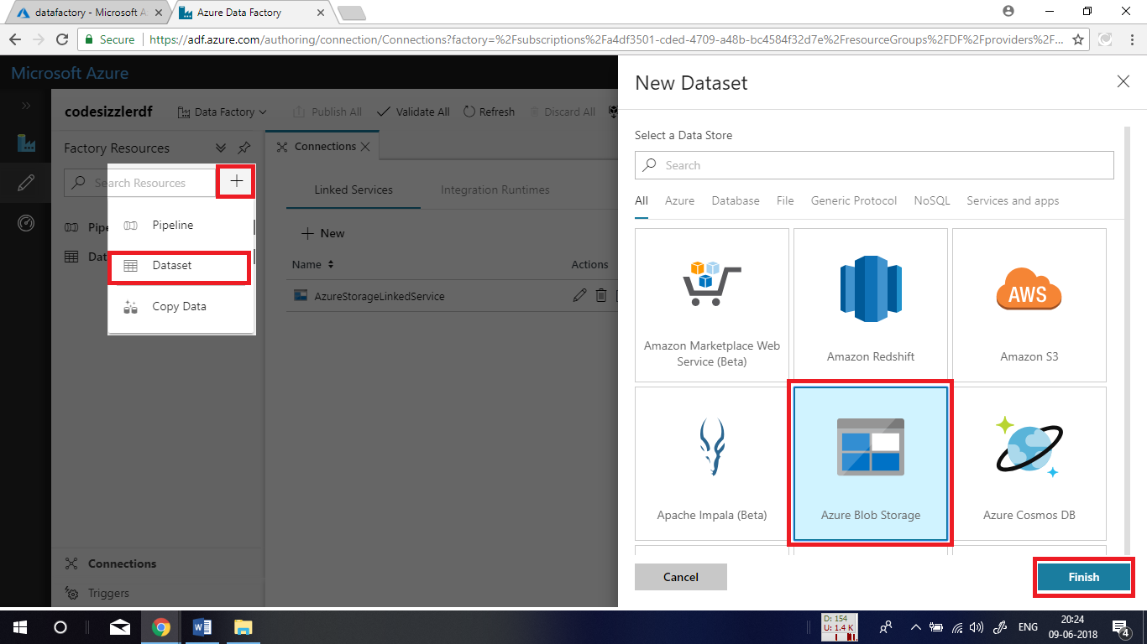

Name it as **InputDataset** as shown below.

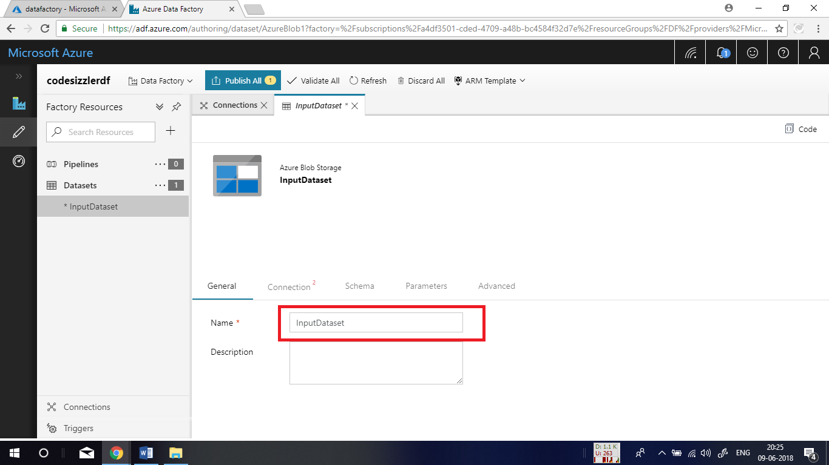

Click on **Connection** and choose the connection that you create previously for the Linked Service dropdown list. Next in the place of file path, chose the file that has to be copied as another copy. For this click on **browse** button and choose the file.

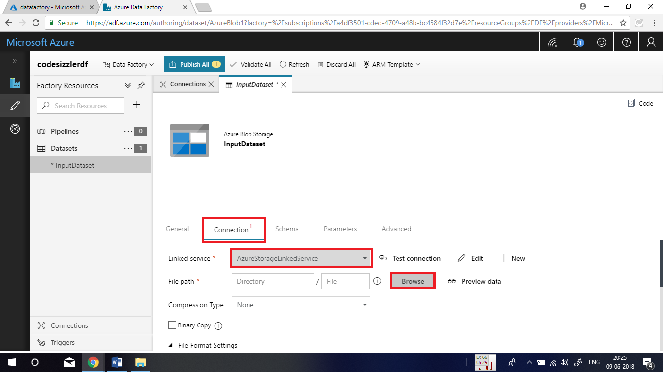

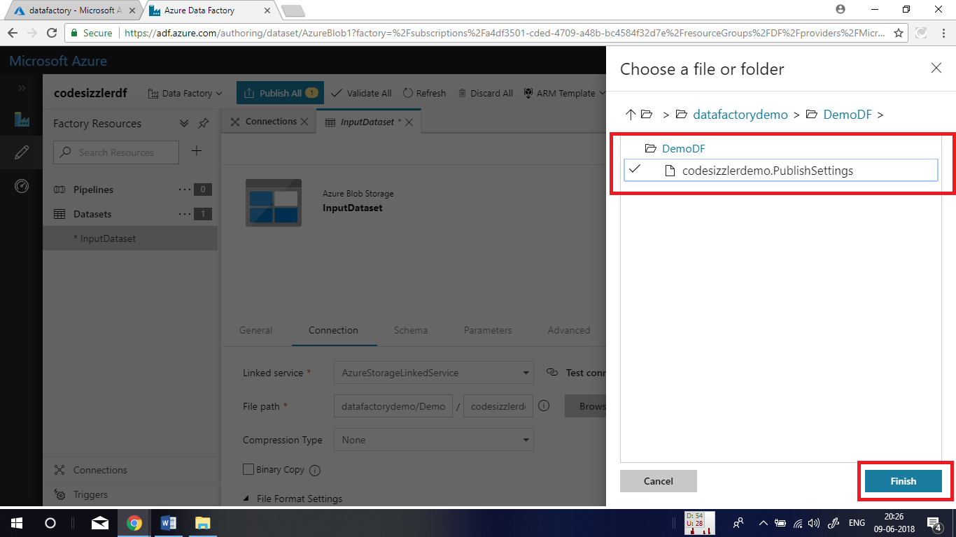

Once again add another **Dataset** with the name as **OutPutDataset.**

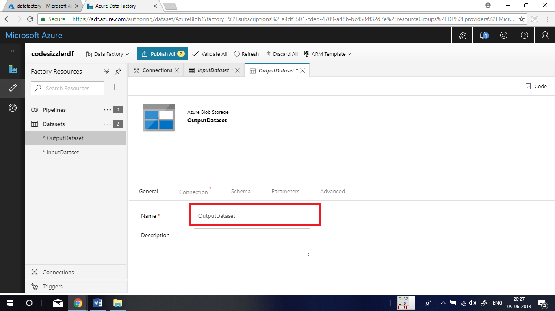

Again, under the **Connection** choose the linked service and next in the file path choose the destination where you like to copy your file. In the file name textbox, use the following function to get an unique name for the file that you copy. The function is

**@CONCAT(pipeline().RunId, ‘.txt’)**

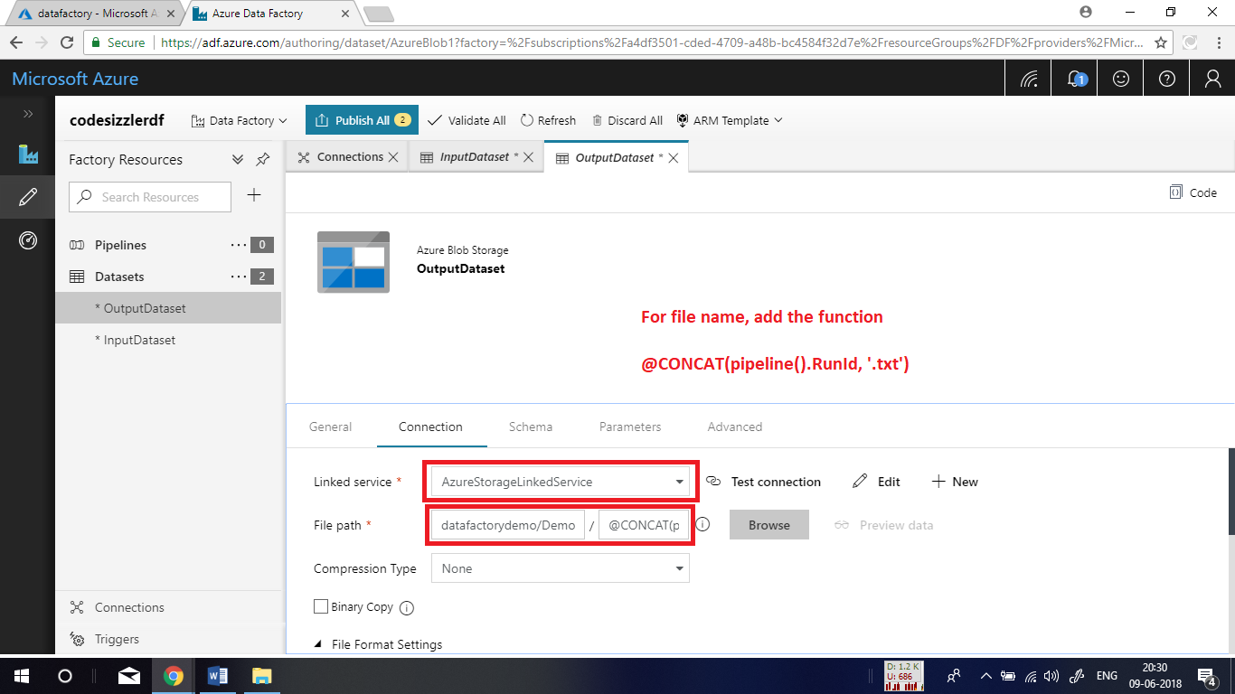

**Adding Pipeline:**

In the left side pane, click on **+** button and choose **Pipeline** to add a pipeline. Name the pipeline as **CopyFromBlobToBlob.** Then expand the **DataFlow** in the left side and drag and drop the **Copy** function into the designer window.

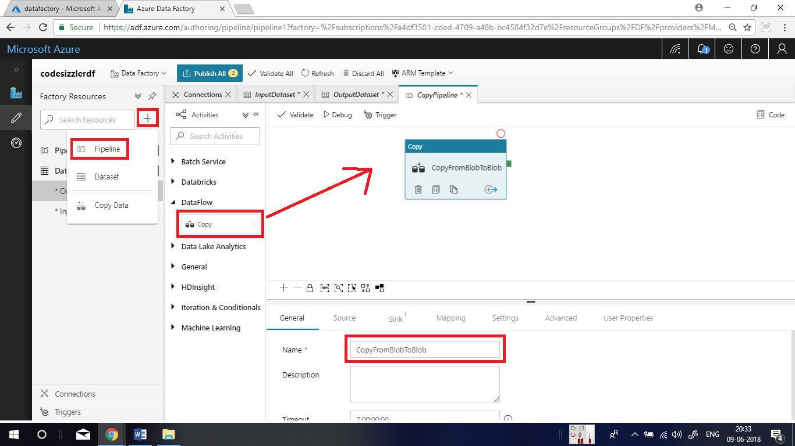

After adding the function, click on **Source** and choose **InputDataset** as **Source** **Dataset**.

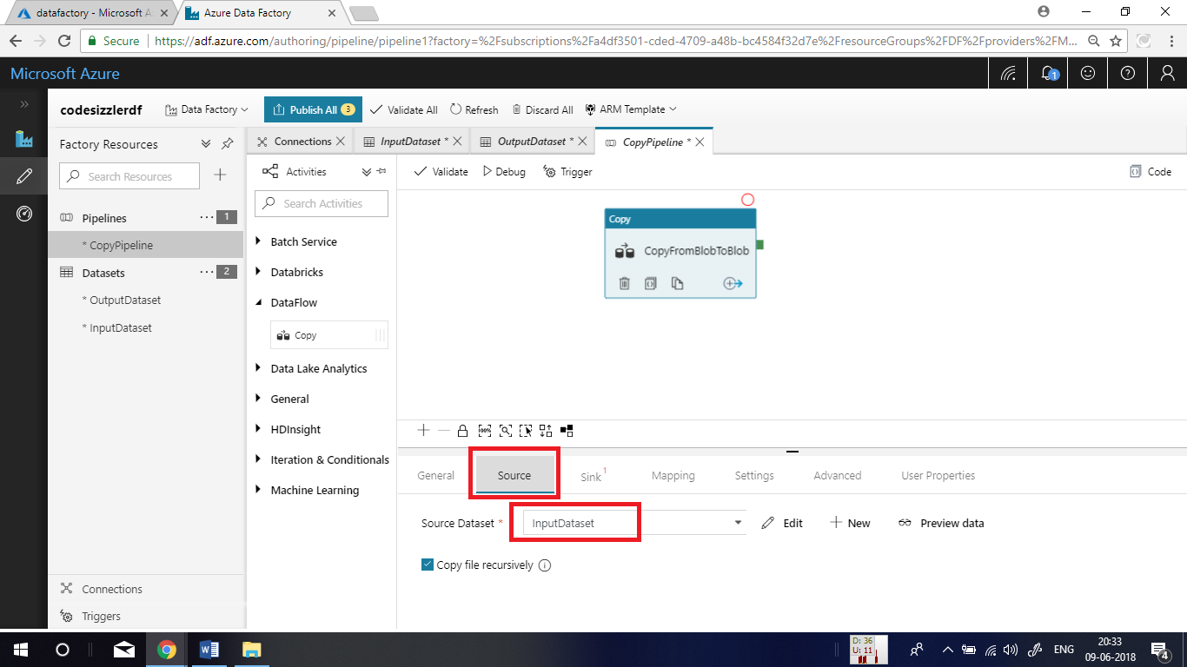

Now, click on **Sink** option and choose **OutputDataset** for **Sink Dataset.** After this click on **Validate All** option at the top to check the pipeline design that you made.

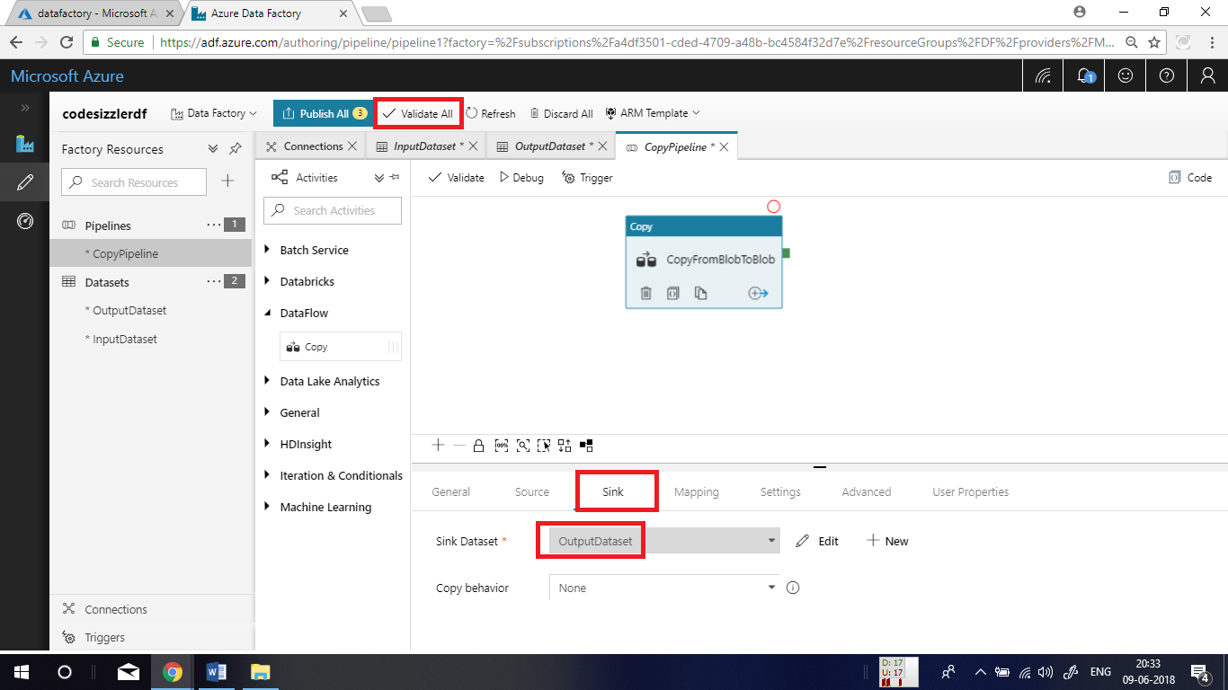

You will get a response like this if there are no validation errors.

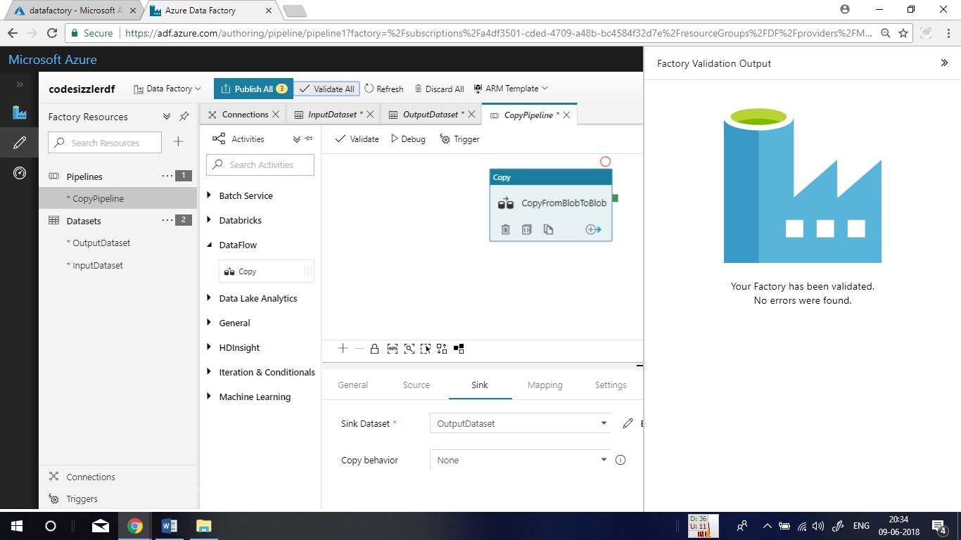

After successful validation, click on **Debug** option to execute the pipeline that you have implemented.

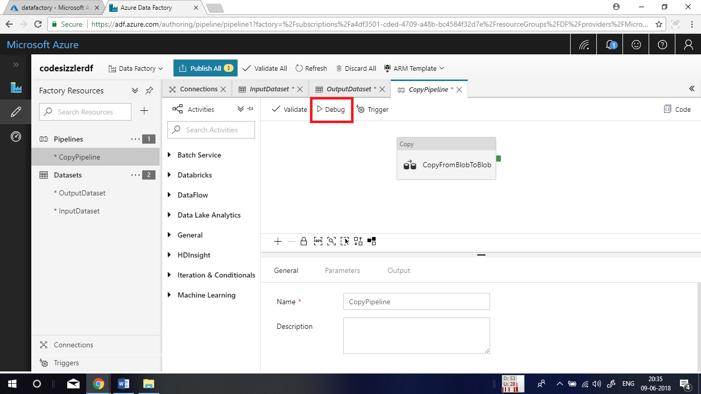

On a successful execution of the pipeline, you will get output as shown below.

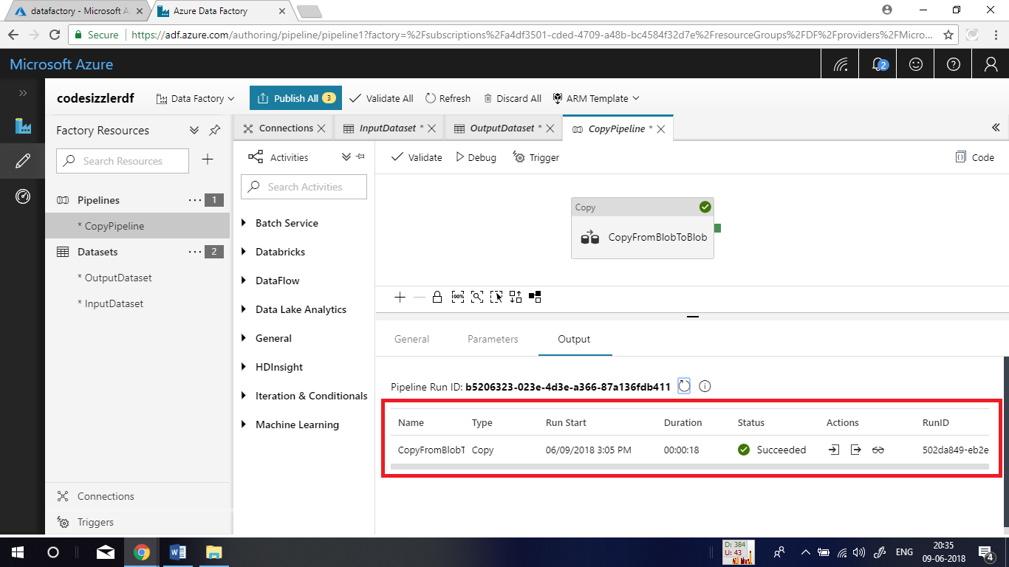

Go back to Azure portal and check inside the container where you made the blob copy. You will be able to find a new blob in there with the runtime ID as its name.

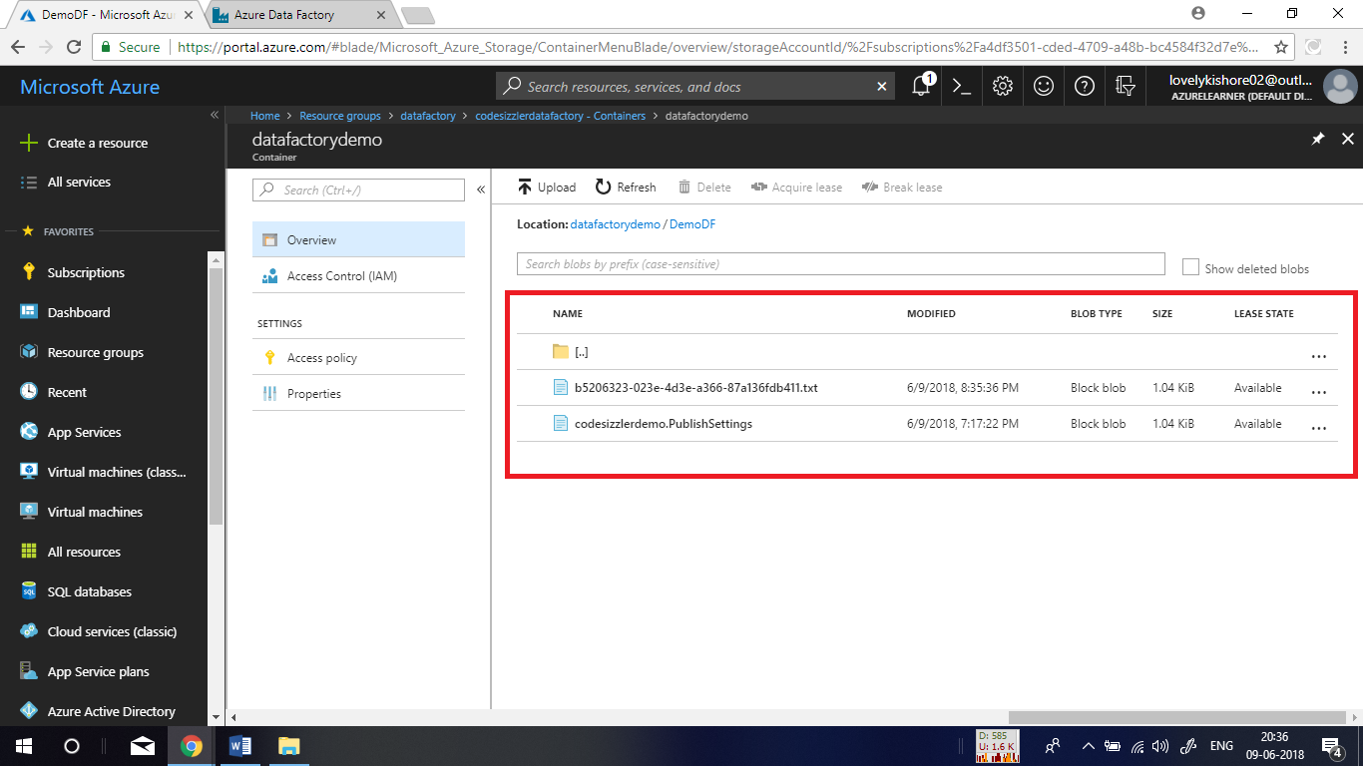

**Triggering Pipeline:**

In the management portal, click on **Trigger** and choose **Trigger Now** option. Then click on **Finish** button to start trigger. If you want to initiate a trigger at some specific time, click on **New/Edit** option and create a new schedule for the trigger.

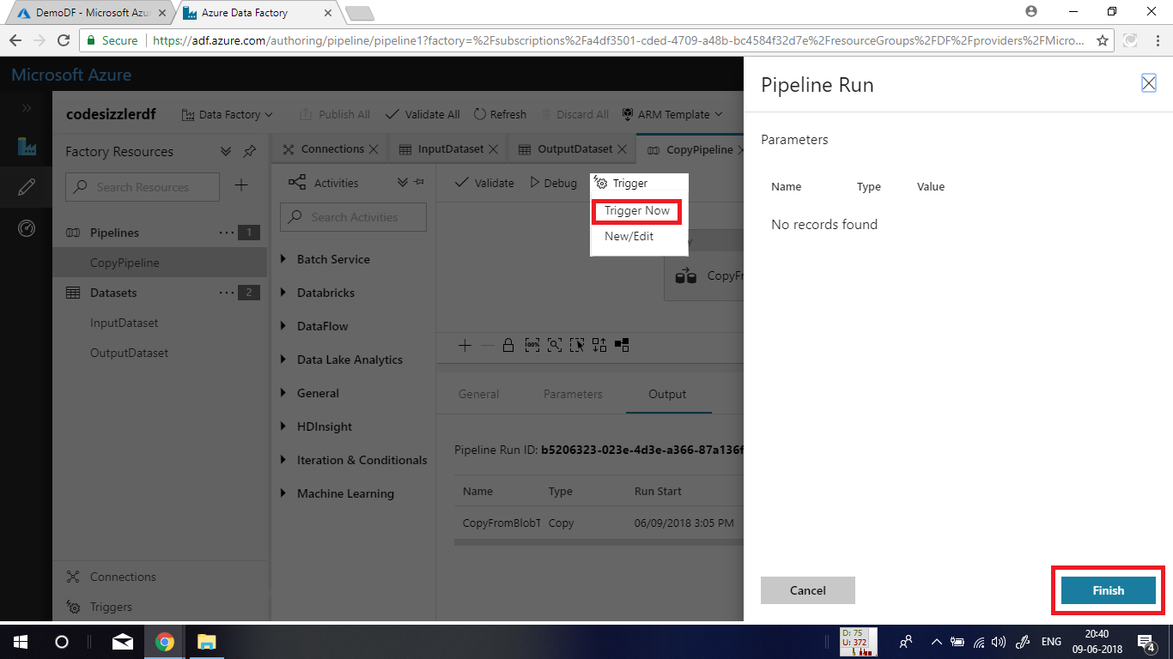

**Monitoring Pipeline:**

In the left side menu, click on the clock symbol to get into the **Monitoring** page. In there click on the below denoted symbol to view the activity runs.

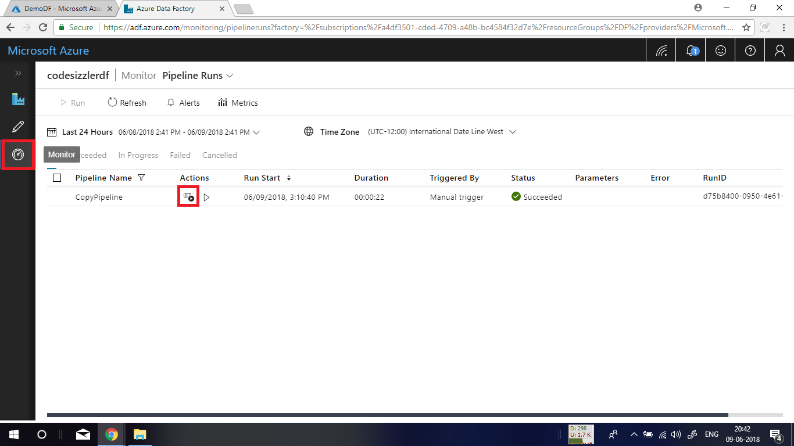

In the next blade, click on the **Sun Glasses** icon to visualize the pipeline activity that you executed with a detailed report.

